Lifting Equipment
Used in two different ways in LOLER:
1. A generic term used to cover all lifting accessories and appliances
2. A more specific meaning covering lifting appliances, their anchorages and fixings.
Lifting Accessories
Any device such as a sling, eyebolt, spreader beam etc. used to connect the load to a lifting appliance but which is not itself part of the load or the appliance.
Lifting Machine/Lifting Appliance
A device or mechanism, such as a winch, sheave block or chain block, which does the work in lifting the load or provides the means of movement, or the supporting structure and anchoring devices for such a mechanism, e.g. runway, which may also permit a suspended load to be moved in the horizontal plane.

Coefficient of Utilization (CoU), Factor of Safety (FOS), Working Coefficient
It is a factor which is applied to the MBL to determine the WLL. It varies with the product to take account of the susceptibility to damage and considers the type of stresses the item will meet in normal use.

Mode Factor
A factor applied by the user (slinger or rigger) that takes into account the geometry of a sling assembly to obtain the maximum load it may lift for a particular mode of use.

Working Load Limit
WLL (sometimes called maximum SWL)

The maximum load or mass that an item of lifting equipment is designed to sustain, i.e. raise, lower or suspend. This is the load required to be marked on an item by the product standards.

Safe Working Load (SWL)
The maximum load or mass (as certified by a competent person) that an item of lifting equipment may raise, lower or suspend under particular service conditions. It is the SWL which is required to be marked on the item by LOLER and which appears on any report of thorough examination.
Note: The SWL will normally be the same value as the WLL or the maximum safe working load but it may be less.

The Minimum Breaking (or failure) Load (MBL)
The minimum breaking load is the calculated load at below which the item will not break or fail due to distortion.

Supply of Machinery (Safety) Regulations 2008

Lifting Equipment must be designed and built to sustain a static overload.

Manually operated machines & Lifting accessories 1.5 x WLL
Other machines 1.25 x WLL

Machinery must be capable of sustaining a dynamic overload of: 1.1 x WLL

PUWER: Provision and Use of Work Equipment Regulations 1998 applies to all work equipment

LOLER: Lifting Operations and Lifting Equipment Regulations 1998 applies to lifting equipment in addition to PUWER

Maximum fixed periods for thorough examinations and inspection of lifting equipment as stated in regulation 9 of LOLER are: -

- Lifting Accessories & Man-Riding Equipment 6 months
- Lifting Equipment 12 months

Steel Grades Used in Lifting Equipment

- Grade 4 (M) has a breaking strength of 400 N/mm²
- Grade 6 (S) has a breaking strength of 600 N/mm² (BS EN 818 states 630 N/mm²)
- Grade 8 (T) has a breaking strength of 800 N/mm²
- Grade 10 (V) has a breaking strength of 1000 N/mm²
- Grade 12 (W) has a breaking strength of 1200 N/mm²
Load
𝑀𝑒𝑐h𝑎𝑛𝑖𝑐𝑎𝑙 𝐴𝑑𝑣𝑎𝑛𝑡𝑎𝑔𝑒 = or MA = W/P
Effort

𝐷𝑖𝑠𝑡𝑎𝑛𝑐𝑒 𝑚𝑜𝑣𝑒𝑑 𝑏𝑦 𝑒𝑓𝑓𝑜𝑟𝑡
Velocity Ratio (𝑉𝑅) =
𝐷𝑖𝑠𝑡𝑎𝑛𝑐𝑒 𝑚𝑜𝑣𝑒𝑑 𝑏𝑦 𝑙𝑜𝑎𝑑

Mechanical Advantage
Efficiency = x 100
Velocity Ratio

Rating of Slings

The Uniform Load Method

Single leg sling : 1.0 x WLL of a single leg
Two leg sling 0-45° (included angle 0-90°) : 1.4 x WLL of a single leg
Two leg sling 45°-60° (included angle 90°-120°) : 1.0 x WLL of a single leg
Three and four leg sling 0-45° (included angle 0-90°) : 2.1 x WLL of a single leg*
Three and four leg sling 45°-60° (included angle 90°-120°) : 1.5 x WLL of a single leg

 | 0°-60°  0°- 90°(included angle) | 45°-60°  90°-120° (included angle)
Single leg sling | 1.0 x WLL of a single leg
2 leg sling | 1.4 x WLL of a single leg | 1.0 x WLL of a single leg
3 & 4 leg sling | 2.1 x WLL of a single leg | 1.5 x WLL of a single leg

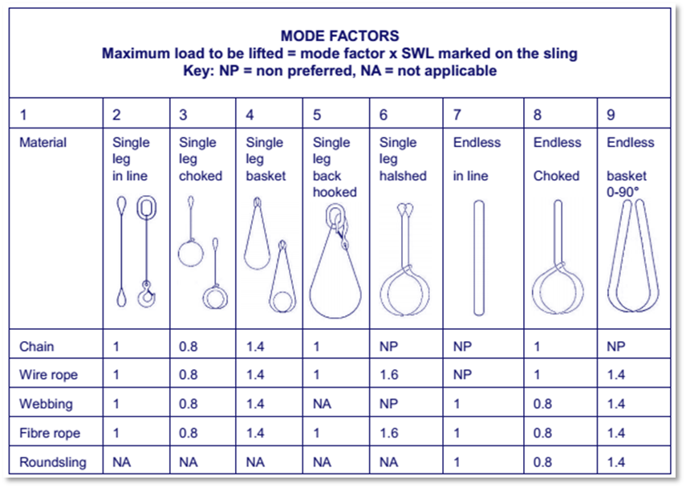

Wire Rope Slings
Standards

Wire rope slings are now manufactured to BS EN 13414-1: 2003, Steel wire rope slings – Safety – Slings for general service.
The rating of slings in BS EN 13414-1 takes account of the termination efficiency before applying a factor of safety of 5:1

BS EN 12385 - Steel wire ropes – Safety
BS EN 13411 - Terminations for steel wire ropes – Safety
BS EN 1677 - Components for slings – Safety

Defects of Wire rope
- Broken wires due to fatigue.( 5% of broken, worn or corroded wires in any length (L=10x Rope dia) (crown wire breaks, valley wire breaks -)
- Reduction in rope diameter due to failure of the inner core.
- Corroded wire rope leads to loss of metallic cross-section.
- Wave formation in wire rope.
- Increased rope diameter.
- Kink caused by incorrect spooling of the wire rope on to the hoist drum.

Wire Rope Grips

The grips in a connection should be spaced evenly along the wire rope at distances between adjacent grips of approximately six times the rope diameter.

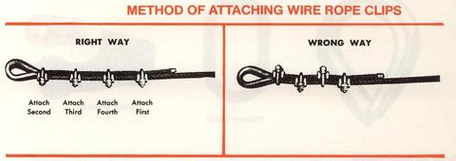

CHAIN AND CHAIN SLINGS

Steel chain is generally 5 to 6 times heavier than wire rope.
Chain have a longer working life than that of wire rope. As it is very tough and is less prone to damage in use.

Chain and Chain Sling Standards

BS EN 818 is the harmonized European Standard for chain and chain slings.
It has been prepared to enable manufacturers to demonstrate that they are meeting the essential safety requirements of the European Machinery Directive.

• Chain intended for use in chain sling assembly is graded using numbers
- BS EN 818 currently uses grade 4 and 8 steel for chain manufacture
- The grade of chain intended for sling manufacture formerly known as grade T is now grade marked 8

• Chain intended as load chain for lifting appliances is letter graded
- BS EN 818-7 covers grade T chain (calibrated chain as it was previously known) of three types: T, DAT and DT

Medium and Fine Tolerance Chain

Medium tolerance chain, intended for sling manufacture, needs to be more ductile to withstand shock loading.

Fine tolerance chain may be recognized in two ways.
It has a bright finish and of course there is also the grade mark.

Note: Slings made in the UK between 1981 and 1997 may show the letter ‘T’.

Medium Tolerance

Medium Tolerance chain is used only for chain slings.
In accordance with BS EN 818-4 and 818-5, the grades used are 4 and 8.

Grade 4 chain slings are covered by BS EN 818-5
Grade 8 chain slings are covered by BS EN 818-4

Medium Tolerance chain is more ductile than Fine Tolerance chain and tolerates a degree of shock loading.

Fine Tolerance chain is used only for lifting appliance applications (hoists)
In accordance with BS EN 818-7, the grades used are T, DT and DAT.
Fine Tolerance chain is less ductile than Medium Tolerance chain.

Manufacturer’s Test Requirements

In the case of grade 8 Medium Tolerance chain, the manufacturers test force is higher than the customary 2 x WLL. It is actually set at 2.5 x WLL. It is intended that this is the initial test, which is not repeated.

Mechanical Assembly Chain Slings
BS EN 818-4 covers Grade 8 mechanically assembled chain slings Fittings for mechanically assembled slings are available in many types, all covered by BS EN 1677.

TEXTILE SLINGS – FIBRE ROPE AND FIBRE ROPE SLINGS (TEXTILE ROUNDSLINGS)

The current European standard for the manufacture and verification for textile round slings is BS EN 1492-2.

This standard requires textile round slings to have a minimum factor of safety of 7:1
Where metal fittings are included as part of the sling, it is a requirement of the standard that the fittings must conform to the relevant part of BS EN 1677.

Effects of Temperature

Polypropylene, manila, sisal and hemp fibers are suitable for use in the temperature
Range - 40°C to 80°C.
Polyester and polyamide are suitable for use in the range - 40°C to 100°C.

Type of webbing sling | Acid | Alkali | Solvents, tars, paints etc. | water | Sunlight / UV | Elongation
Polyamide |  |  | Not good | 10% |  | 40%
Polyester |  |  | Not good |  |  | 5%
Polypropylene |  |  |  |  |  | >5% & 40%<
Natural fibers |  |  |  | Not good

Marking Requirements

The required marking must be on an appropriately colored label, signifying the material from which the sling is made. The marking must give at least the following information:

• Traceability code
• WLL
• Material of the sling
• Nominal length
• Grade of any fittings
• Number and part of the standard BS EN 1492-1
• Manufacturer’s name
• Marking required by legislation (i.e. the CE mark)
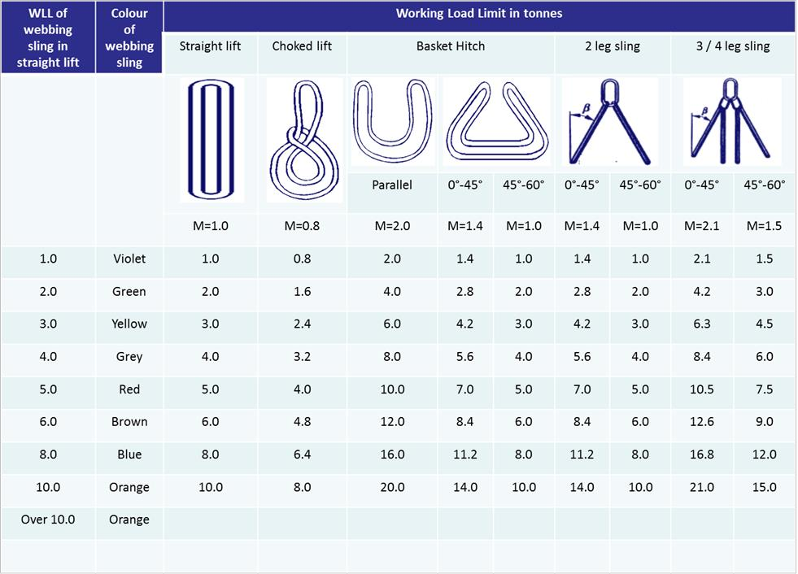
MANUAL CHAIN HOISTS

Manual Chain Hoists

Applications where:

• A permanent installation for infrequent use is required
• A temporary installation for erection or maintenance purposes is required
• Precise location of the load is required
• A suitable power supply is not available

The current Harmonized Standard for chain hoists is BS EN 13157:2004, Cranes – Safety – Hand Powered Lifting Equipment.

Chains shall be in accordance with BS EN 818-7, for fine tolerance short link chains (grade T)

The coefficient of utilization shall be at least 4 for welded load bearing calibrated link chains.

The free end of the load chain shall be fitted with a chain end stop to prevent it from passing through completely.

This end stop shall withstand without rupture 2.5 times the static chain tensile force at rated capacity

The Use of Chain Hoists

Caution!

Most chain hoists are designed to be operated by a single person – The chain offers enough leverage to operate at maximum load, if more than one person is required it is possible that the load exceeds the WLL, the appliance is in need of maintenance or a combination of the two.

Care should be taken to ensure the hoist is not subjected to shock loading.

Care should be taken not to drop the hoist as this can cause:

• Damage to the casing
• Damage to gears or other mechanisms
• Distortion of the hoists alignment

If suspended from a power operated crane hook for accurate load positioning, the SWL of chain hoists should be reduced by 15% to allow for the effects of dynamic loading or shock loading which may occur.
LEVER HOISTS

Hand operated lever hoists are widely used for lifting and pulling applications.

The current Harmonized Standard for lever hoists is

BS EN 13157:2004, Cranes – Safety – Hand Powered Lifting Equipment

Chains shall be in accordance with:
• EN 818-7, for fine tolerance short link chains (grade T);
• ISO 606, Short pitch transmission precision roller chains and chain wheels.

The coefficient of utilization shall be:

• At least 4 for welded load bearing calibrated link chains
• At least 4 for roller chains
The free end of the load chain shall be fitted with a chain end stop to prevent it from passing through completely. This end stop shall withstand without rupture 2.5 times the static chain tensile force at rated capacity.

The Use of Lever Hoists

- The load chain should not be used to form a sling around a load and back hooked as this would remove the swivel action of the bottom hook, possibly leading to the chain links becoming twisted and the links at the point of choke which can bend, distort and, at worst, crack the weld.
- No part of the load or slings should be in contact with the stress point of the hook as this could distort and open the hook.
- Do not overcrowd the hook.

Most blocks are designed to be operated by:
• Single person – handle offers enough leverage to operate at maximum load
• Should not be shock loaded

Care should be taken not to drop the block as this can use:
• Damage to the casing
• Gears or other mechanisms
• Distortion of the blocks alignment

If suspended from a power operated crane hook for accurate load positioning, the SWL of lever hoists should be reduced by 15% to allow for the effects of dynamic loading or shock loading which may occur.

JAW WINCHES

Jaw winches are extremely versatile pieces of lifting equipment. Due to the rope not being an integrated part of the winch, different lengths of rope can be supplied for each winch.
They are widely utilized as pulling machines as well as lifting which may permit a lower factor of safety giving a higher Working Load Limit when the winch is used in this application.

The current standard covering jaw winches is BS EN 13157 which requires a minimum factor of safety for lifting in general application of 4:1.

Load Rope

The wire rope supplied for use with a jaw winch should be considered as integral a part of the mechanism as a load chain of a chain hoist.

Safe Use of Jaw Winches

The following points should also be observed:
• The machine must not be used to raise, lower or suspend a load more than the Working Load Limit of the machine. When using multiple jaw winches, care must be taken to ensure the share of the load taken by any one winch does not exceed the WLL
• Kinks and broken wires in the load rope can easily jam the winches mechanism rendering the winch inoperative
• Only use the handle from the manufacturer,
• Do not attempt to operate both raise and lower lever at the same time
• The raising lever is fitted with shear pins specific to the machine as a safety device, these must not be replaced

POWERED LIFTING MACHINES

BS EN 14492-2: 2006 + A1: 2009 - Cranes - Power driven winches and hoists - Part 2

OFFSHORE CONTAINERS

Offshore Container Standards

The following list of standards are all applicable to offshore containers:

BS 7072: 1989 – British Standard code of practice for the inspection and repair of offshore containers (Withdrawn)

BS EN 12079-1: 2006 – Offshore containers - Design, manufacture and marking

BS EN 12079-2: 2006 – Offshore containers lifting sets - Design, manufacture and marking

BS EN 12079-3: 2006 – Offshore containers and lifting sets – Periodic inspection, examination and testing

Standard for Certification DNV 2.7-1: June 2013 – Offshore containers

Lifting Set Requirements

The lifting set which is utilized for lifting the offshore container must be specifically designed for the maximum gross mass of the container to be lifted.

There are enhancement factors that must be considered when designing these lifting sets, due to the dynamic motions that an offshore container will experience when being lifted offshore.

There must also be a top leg (forerunner) fitted if the lifting set does not hang over the long side of a container to a specific height. This will ensure the rigger does not have to put themself in danger by standing on top of a container.

MOBILE CRANES

